Knuckey Lagoon Recreation Reserve

Management Committee Meeting

**MINUTES**

**Thursday 2/02/2023**

Meeting held commencing 5:45pm

at Knuckey Lagoon Recreation Reserve

**Kate Townsend, Sport and Recreation Officer**

 **MINUTES**

Knuckey Lagoon Reserve Committee Meeting

**Held in the Knuckey Lagoon Recreation Reserve**

**on Thursday 02 February 2023 at 5:45pm**

1. Opening of Meeting

5.45pm

1. Acknowledgement of Traditional Owners
2. Attendees

|  |  |
| --- | --- |
| Kate Townsend | Sport and Recreation Officer (SRO) |
| Councillor Rachel Wright | Litchfield Council |
| Russ Swan | Top End Gem and Mineral Club |
| Millie Feeney | Berrimah Scouts |
| Nimnuan Walters | NT Thai Association |

1. Apologies and Leave of Absence

|  |  |
| --- | --- |
| Saramat ‘Tou’ Ruchkaew | NT Thai Association |

1. Disclosure of Interest

Nil

1. Confirmation of Minutes

December 1, 2022

**Moved: Millie Feeney**

**Carried: Councillor Wright**

1. Monthly Finance Report

**Moved: Millie Feeney   
Carried: Russ Swan**

1. Operations Report

Attachment A.

**Community Benefit Fund Grant Applications.**

* Russ Swam indicated that the Gem Club will be applying for funding to install 1-2 extra-large fans under the eaves outside, the multiple small fans are ineffective. Requested Kate’s support in drafting the application and letter of support.
* Nim indicated that NT Thai Association has not yet determined a plan for an application but requested Kate’s assistance in submitting application
* Milllie indicated that the Scouts will discuss and reach out to Kate if they need assistance.

**Moved: Millie Feneey**

**Carried:** Nimnuan Walters

1. Business Arising from the Minutes

|  |  |
| --- | --- |
| Issue | Action |
| Contact numbers for Committee Members | Please provide details to SRO |

1. Other Business

* Enquiry from Councillor Wright regarding availability of funding to complete painting. Kate indicated that none of the Recreation Reserves currently have sufficient budget for painting.
* Enquiry from Councillor Wright regarding Masterplan development, Kate will have a consultation plan to present at the next meeting with initial consultation to occur in May.

**Action for Committee** to discuss future needs of their groups over the next 10 years with their members.

* Russ Swan asked if repair and maintenance items could be added to the register.
  + Leaking tap in lady’s bathroom
  + No paper towels in men’s bathroom
  + Soap dispensers need refilling.

1. Next Meeting

Next meeting Thursday 6 April 2023 at time 5.45pm Knuckey Lagoon Recreation Reserve.

1. Close of Meeting

6.28pm

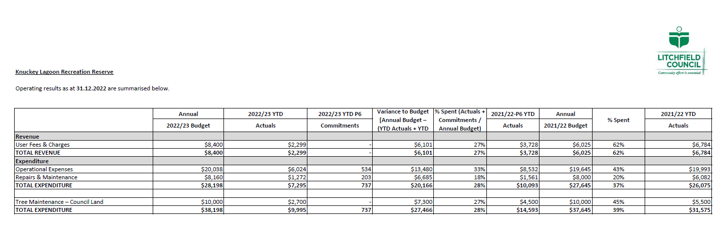



|  |
| --- |
| Knuckey Lagoon Operation Report February 2023 |
|  |
| Logo, company name  Description automatically generated  Kate Townsend, Sport and Recreation Officer  2 February 2023 |

Utilization

|  |  |
| --- | --- |
|  | Knuckey Lagoon |
| Regular user groups | 4 |
| Casual Bookings | 0 |

Regular User Groups

* Top End Gem Club
* Berrimah Scouts
* Darwin Runners and Walkers Club
* NT Thai Association

Storage

|  |  |
| --- | --- |
| Internal Storage | External Storage |
| Top End Gem Club | Berrimah Scouts |

Financials

**Figures as of 31 October 2022\***

|  |  |  |
| --- | --- | --- |
|  | **2022/23** | **2021/22** |
| Income | **27%** | 62% |
| Operational Expenses | **33%** | 43% |
| Repairs and Maintenance | **18%** | 20% |
| Tree maintenance | **27%** | 45% |

Operational Budget $20,038

Actual: $6024

Maintenance & Repairs

**User groups are asked to submit repairs and maintenance requests to the Litchfield Council CDO as they are identified (not at committee meetings).** Jobs are then prioritized and actioned according to budget with progress reported at meetings. Please communicate updates back to your user groups as appropriate.

Work completed this period:

* January - New Mirrors in all three bathrooms

(Appendix A) Repairs and Maintenance log lists, prioritizes, and costs each job reported to Council from contractors and user groups. This allows jobs to be actioned according to need and budget.

Communication and PROMOTION

Cleaning Contract RFQ

Council has awarded the cleaning contract to Ironbark Service NT on 13 January 2023. Two submissions of a high standard were received by Council and the successful contract was awarded according to best value for money, ability to understand and deliver on contract requirements and experience undertaking similar sized work.

Ironbark is a Territory Not for Profit, first nations organization which provides employment services to the Litchfield Municipality. The contractor will undertake a spring clean to establish the new service standard going forward before commencing in February. There is an option for renewal or review of the contract in 12 months’ time.

Grant Opportunities

NTG Major Community Benefits Grants of up to $250,000 are again open and will close on 28 February.

As the Management Committee is no longer incorporated, Knuckey Lagoon relies heavily on not-for-profit user groups initiating projects through grant funding opportunities to further develop and improve the facilities.

We encourage each NFP user group to initiate a discussion with their committee on future planning and projects in preparation for consultation for the Reserve Master Plan which will be undertaken this year.

If your organization would like any assistance with grant applications, please reach out to Litchfield’s Sport and Rec Officer.

Upgrades and Improvements

Online Booking System

50% of the funding required for the new system were approved in Budget Review 1, passed by Councillors at the December 2022 Ordinary Council Meeting.

The remaining funds required which are being sourced from Howard Park Reserve, are anticipated to be released at the February Council Meeting, pending support from Councillors.

Security/WIFI Access upgrades

Awaiting final quote.

Appendix A Repairs and Maintenance log

|  |  |  |  |  |  |  |
| --- | --- | --- | --- | --- | --- | --- |
| Location | Description | Action Required | Date | Priority Score | Actioned | Quoted |
| Bathrooms | Flooding whenever showers are used | Plumber/contractor | Apr-22 | 5 |  |  |
| Bathrooms | Taps frequently not turned off completely | change taps | Apr-22 | 2 |  |  |
| Downstairs hallway | skirting board missing | Contractor |  |  |  |  |
| General | Painting tired and chipped | paint | Apr-22 | 2 |  | $3,908 |
| General | Replacement blowers and vacuum cleaner | replacement | Apr-22 | 2 |  |  |
| Kitchen | Tiles Missing from kickboard | Replacement | Apr-22 | 4 |  | $500 |
| Kitchen | Possum entering building via roller door | Block entry | Apr-22 | 5 |  |  |
| Kitchen | Electric Urn leaking | Service | Apr-22 | 2 |  |  |
| Outdoor | BBQs in poor condition | Replacement | Apr-22 | 3 |  |  |
| Stairs | chipped and flaked paint | Needs repainting | May-22 | 5 |  | $1,328 |
| Upstairs | Water damage on left hand side | replace tiles, check roof | Apr-22 | 4 |  |  |
| Upstairs | Hole in floor | Needs patching | May-22 | 5 |  |  |
| Driveway/carpark | Light reflectors on the edge of the road |  |  |  |  |  |
| Carpark | Edging/gutters and line marking |  |  |  |  |  |
| Shed/Building | Pathway needed between buildings |  |  |  |  |  |
| Carpark | Extend road base from carpark to building to increase accessibility |  |  |  |  |  |